About
A simple guide to help new developers set up an environment for developing the Access Labs applications.

Firstly, there are some links below you must refer to before this doc.

New hire enablement plan:
https://mojo.redhat.com/docs/DOC-92816

Access Labs guide | parent doc
https://mojo.redhat.com/docs/DOC-932924

There are something to be clarified in a more explicit way from the stand of a new comer.
Installing IRC client
Setting up an environment that mimics the Access Labs development space
Setting up HTTP proxy
Setting up VPN
Joining mailing lists

Installing IRC client
Step 1:
Install X-chat in any way you know, e.g. #sudo yum install xchat.x86_64
Step 2:
Click “Add” in “Networks” area and input your network name, e.g. “RH”
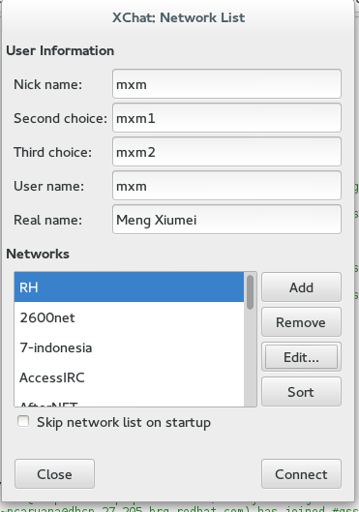
Step 3:
Chose your network and “Edit” to add server and port.
IRC servers: please refer to https://docspace.corp.redhat.com/docs/DOC-43560.
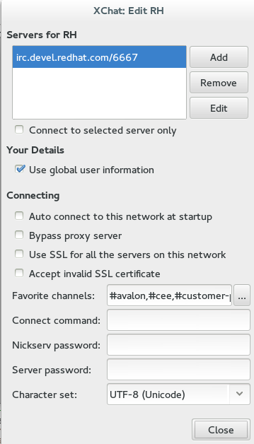
Step 4:
Edit you “Favorite channels” and our team members should add channels below:
#avalon,#cee,#customer-platform,#gss,#gss_china,#jbossas,#jbosscn

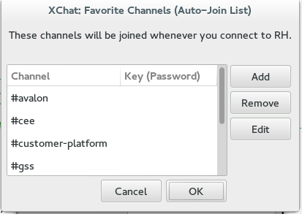

Setting up an environment that mimics the Access Labs development space
Step 1:
Install Apache2.
Step 2:
Create a DDNS Entry and you are going to access the app with username.domain
Step 3:
Set up a virtual host and some proxy passes so that the JS chroming services work in /etc/httpd/conf/httpd.conf.
Note: make sure ssl has been installed and modules/mod_ssl.so has been loaded.
<VirtualHost *:443>
SSLEngine On
SSLProxyEngine On
SSLCertificateFile /etc/httpd/ssl/httpd.pem
SSLCertificateKeyFile /etc/httpd/ssl/httpd.key

ServerName localhost.localdomain

# Example of a passthrough to a local Ruby application
#ProxyPass /labs/ http://localhost:3000/labs/

# Example of a passthrough to a local Java application
#ProxyPass /labs/ http://localhost:8080/labs/

</VirtualHost>

<IfModule mod_proxy.c>
ProxyRequests on
RewriteEngine On
SSLEngine on
SSLProxyEngine on
SSLCertificateFile /etc/httpd/ssl/httpd.pem
SSLCertificateKeyFile /etc/httpd/ssl/httpd.key

ProxyPass /webassets/ https://access.redhat.com/webassets/
ProxyPass /chrome_themes/ https://access.redhat.com/chrome_themes/
ProxyPass /services/ https://access.redhat.com/services/
ProxyPass /click/ https://access.redhat.com/click/
ProxyPass /suggest/ https://access.redhat.com/suggest/
</IfModule>
Step 4:
Execute command “service httpd start” as root and test the proxy using the url https://localhost/webassets/avalon/j/lib/angular/1.2.8/angular.min.js or https://<localhost.localdomain>/webassets/avalon/j/lib/angular/1.2.8/angular.min.js.
If some contents of js are shown, the configuration works.

Setting up HTTP proxy
Set up HTTP proxy squid.apac.redhat.com in your browser with port 3128

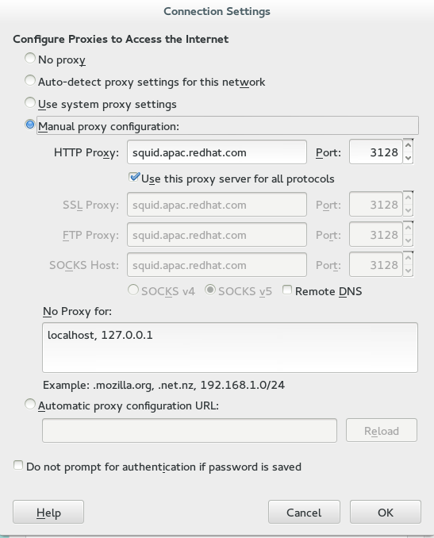

Setting up VPN
Step 1:
Install VPNC in any way you know, e.g. #sudo yum install vpnc.x86_64
Step 2:
Open /etc/vpnc/default.conf and add content below to the file.
#Phoenix
#IPSec gateway vpn-phx2.redhat.com

#Amsterdam
#IPSec gateway vpn-ams2.redhat.com

#Singapore
#IPSec gateway vpn-sin2.redhat.com

#Brisbane
#IPSec gateway vpn-bne.redhat.com

#Beijing
#IPSec gateway vpn-nay.redhat.com

#Tel Aviv
#IPSec gateway vpn-tlv.redhat.com

#Tokyo
#IPSec gateway vpn-nrt.redhat.com

#Raleigh
IPSec gateway vpn-rdu.redhat.com

IPSec ID RH-standard
IPSec secret nodnerip
Xauth username <your userName>
Step 3:
Run vpnc with your ID and pin+token.

Joining mailing lists
Subscribe mailing lists from http://post-office.corp.redhat.com/mailman/listinfo
There are several lists that our team members should join, they are: China-list, access-lab, diagnostics-dev-list and avalon-dev-list.
There will be hundreds of mails being received if you join the mailing lists above, so you can catalog your mails by adding filters to your mail system.
Step 1:
Right click “Folders” on the left of your mail system and chose “New Folder”.
Input a name for your folder, e.g. China-list.
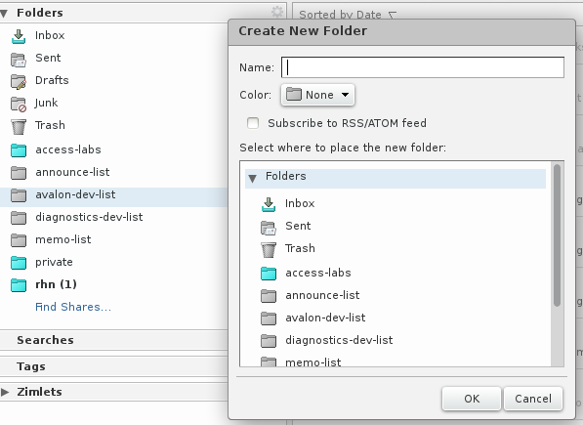
Step 2:
Switch to tab “Preferences” and click “Filters”, you'll see the “Incoming Message Filters” setting page.
Rules can be added and mails will be cataloged to the folder that you created in the previous step by clicking 'New Filter”.
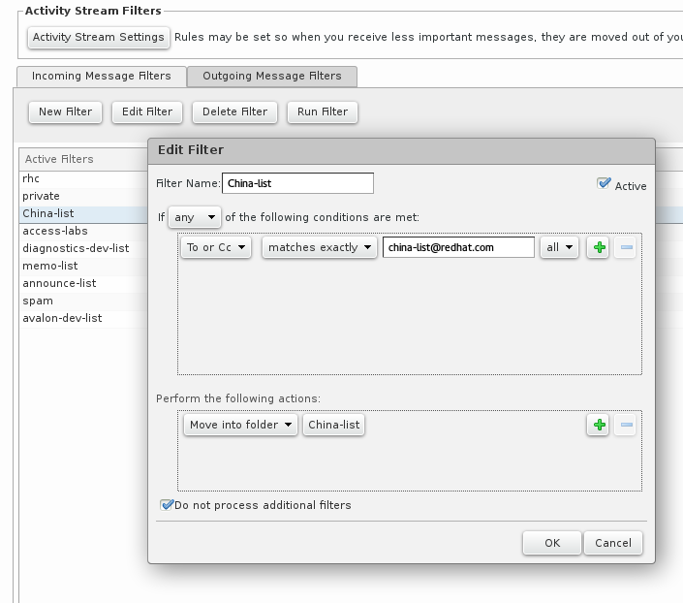Step 3:
Chose a filter in the list and run it, your mails have been received in “inbox” will be moved to specific folder according to the rules.
